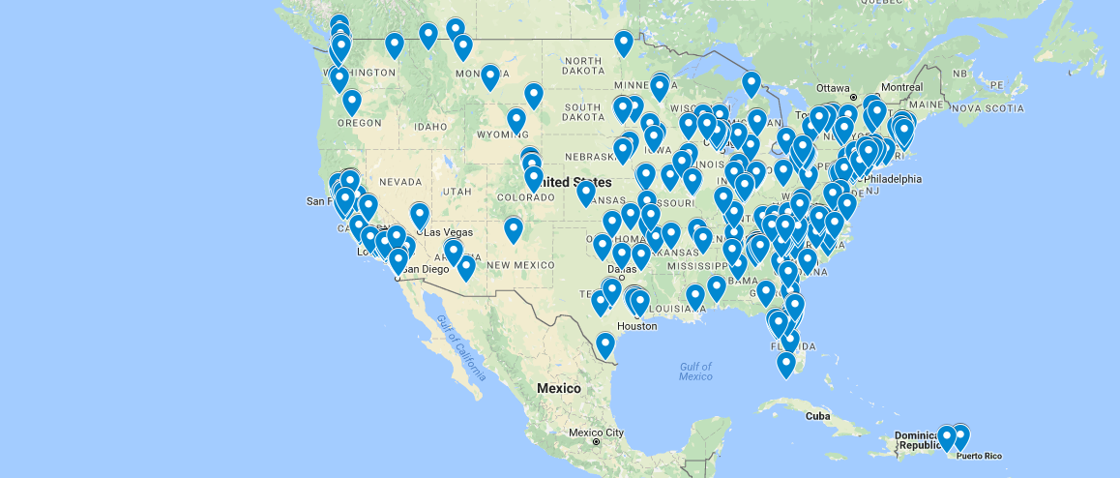
1001 New Worshiping Communities (NWCs)
General Assembly (2012) – Calls for 1001 NWCs over 10 years
Hope to shift from inward-focus of denomination to outward focus
Call not just to start NWCs – but to support them as well
http://presbyterianmission.org/ministries/1001-2
New
Seeking to make and form new disciples of Jesus Christ
Taking on varied forms of church for our changing culture
Worshipping
Gathered by the Spirit to meet Jesus Christ in Word and Sacrament
Sent by the Spirit to join God’s mission for the transformation of the world
Community
Practicing mutual care and accountability
Developing sustainability in leadership and finances
Sarasota Statement
Written by eight people in January of 2017
“We believe in times of need or crisis, we are called to turn to the biblical and theological roots of our Christian faith to remember our identity as disciples of Jesus Christ and say anew what we believe.”
Response to ideological division
Not a directive from General Assembly
Designed to inspire others to write new faith statements
“We encourage groups of Presbyterians, in a rich and colorful diversity of relationships, both within and beyond congregations, to conceive and declare their own faith statements, proclaiming the light of Christ.”
https://nextchurch.net/the-sarasota-statement/

