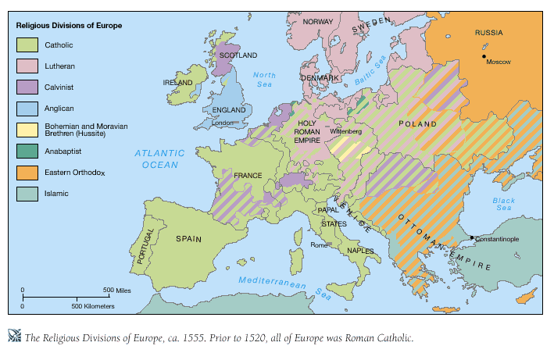
Seeds of Reformation
John Wycliffe (c.1325 – 1384)
English (Oxford Seminary Professor)
Attacked privileged status of Clergy and church luxury
Translated Bible from Latin Vulgate into Middle English
Believed that Christians should rely solely on the Bible
Jan Hus (c. 1369 – 1415)
John Wycliffe by Thomas Kirby (1828)
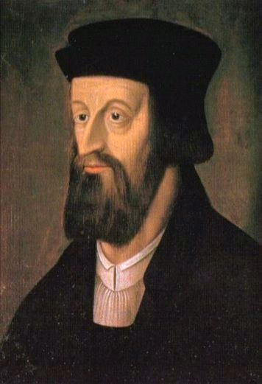
Czech (Priest in Prague)
Translated Wycliffe’s works into Czech
Ignored Papal authority during the Papal schism
Spoke out against indulgences
Believed Christ was head of the Church, not the Pope
Burned at the stake
Desiderius Erasmus Roterodamus (1466-1536)
Dutch (Priest and Humanist of Rotterdam)
Published New Testament in Greek and Latin
Jan Hus
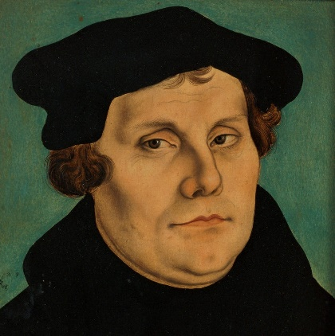
Martin Luther (1483-1546)
German (Augustinian Monk and Professor in Wittenberg)
Theological Arguments:
Indulgences are immoral and ineffective
Salvation is a gift of God’s Grace
Bible is only source of knowledge of God
All baptized Christians are priests
Bible should be made available in local language
Clergy should be able to marry
Martin Luther by Lucas Cranach the Elder (1529)
95 Theses (Oct. 31, 1517)
Now considered the start of the Reformation
Led to Luther’s Excommunication in 1521
Why does not the pope, whose wealth today is greater than the wealth of the richest Crassus, build the basilica of St. Peter with his own money rather than the money of poor believers?
~Martin Luther, Thesis 86, 95 Theses
Diet of Worms (1821)
Told he was acting as a Heretic, Luther stood by his work as based solely in the Bible
The Five Solas
Latin slogans from the Reformation
By Faith alone (sola fide)
By Scripture alone (sola scriptura)
Through Christ alone (sola Christus)
By Grace alone (sola gratia)
Glory to God alone (soli Deo Gloria)
Sacraments
Signs of the real presence and power of Christ in the Church
Seal believers in redemption
Renew believers in identity as people of God
Marks believers for service to God
Baptism + Communion
Instituted by God and commended by Christ

