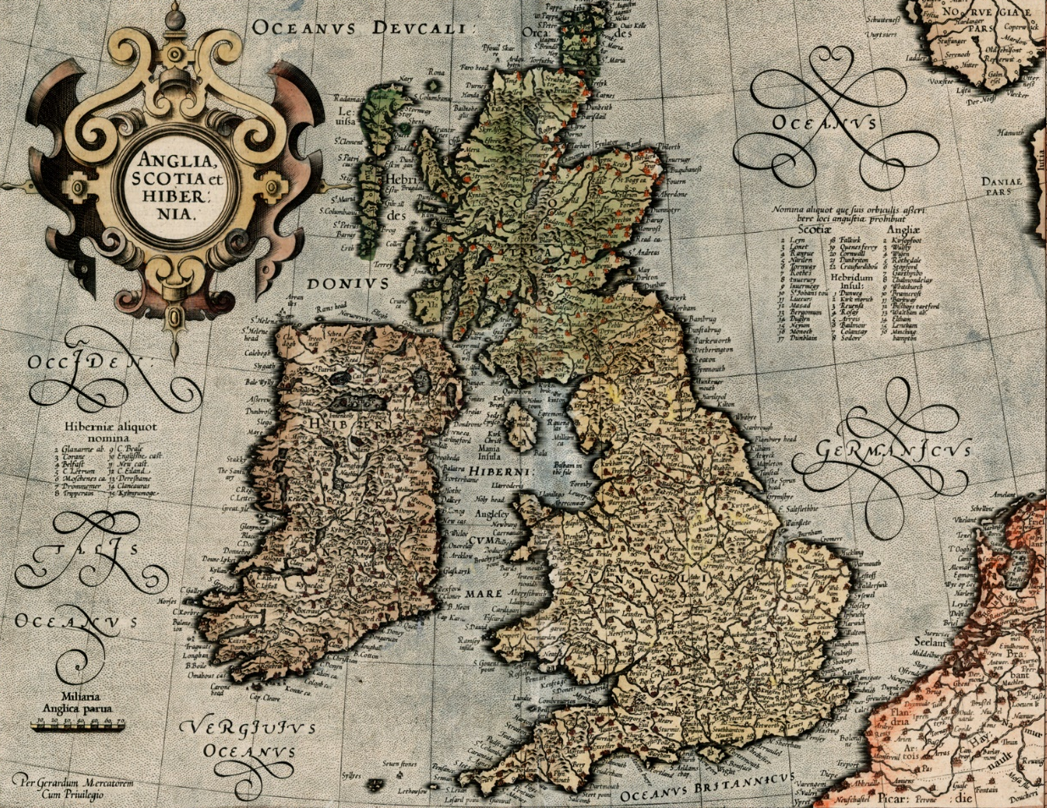
John Knox (c. 1513 – 1572)
Mercator’s first projection of the British Isles, 1595
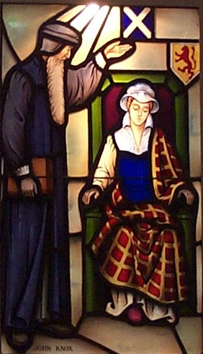
Scottish minister and theologian
Studied under Calvin in Geneva
First Blast of the Trumpet Against the Monstrous Regiment of Women (1558)
Polemic against women monarchs
Written against English Queen Mary Tudor and Scottish Regent Mary of Guise
Primarily addressed Catholicism as evil, and women rulers as unnatural
Published just as Queen Elizabeth came to the throne in England
The Forme of Prayers (1560)
A guide to worship
Not specifically constrained like the Book of Common Prayer
The First Booke of Discipline (1560)
Described Presbyterian polity and order in detail
Adopted by Scottish Parliament
Made room for transition from bishops to Presbyteries
John Knox Admonishing Mary, Queen of Scots (2005)
Window in Covenant Presby. Church, Long Beach CA
Politics influenced by Theology
Universal Education
Revolt against tyranny
Government should assist in caring for indigent and poor
Thence comes that continual battle which is between the flesh and the Spirit in God’s children… Other men do not share this conflict since they do not have God’s Spirit, but they readily follow and obey sin and feel no regrets, since they act as the devil and their corrupt nature urge. But the sons of God fight against sin; sob and mourn when they find themselves tempted to do evil; and if they fall, rise again with earnest and unfeigned repentance. They do these things, not by their own power, but by the power of the Lord Jesus, apart from whom they can do nothing.
~Scots Confession (3.13)
Scots’ Confession (1560)
Written in four days by “The Six Johns”, led by John Knox
Request from Parliament of Scotland to help in the reformation of the country
Based on Calvin’s theology and Knox’s polity
Parliament approved it, but Mary Stuart (Mary, Queen of Scots) did not
First Reformed confession in English language
Continuity with Christians of the ancient church
Parallel structure with Apostles’ Creed
Against the Catholic Counter-Reformation started at Trent in 1546
Theological Content:
Election – God’s choice of us combined with Jesus’ choice to die for us
Not all of the visible church are of the true church
Discipline is necessary for living a Christian life
Signs of the True Church:
True Preaching of the Word;
Right Administration of the Sacraments;
Upright Administration of ecclesiastical discipline
The Reformed heritage has called upon people to bring to worship material offerings which in their simplicity of form and function direct attention to what God has done and to the claim that God makes upon human life. The people of God have responded through creative expressions in architecture, furnishings, appointments, vestments, music, drama, language and movement. When these artistic creations awaken us to God’s presence, they are appropriate for worship. When they call attention to themselves, or are present for their beauty as an end in itself, they are idolatrous. Artistic expressions should evoke, edify, enhance, and expand worshipers’ consciousness of the reality and grace of God.
~Directory for Worship (W-1.3034)
Music + Arts
Church of Scotland allowed only Psalms to be sung
Designed tunes and texts to work together
Iconoclasm vs. Prayerful Engagement
“Music as prayer is a worthy offering to God on behalf of the people” (W-2.1004)

