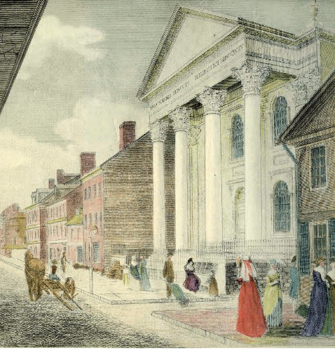
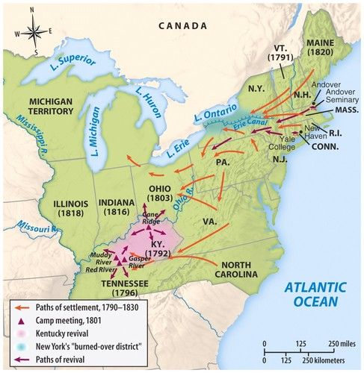
Polity: How the Church is Organized
First Presbyterian Church, Philadelphia,
William Birch & Son, 1800
Polity rules set out in church constitution: Book of Confessions + Book of Order
Book of Confessions contains expressions of particular Christian identity
Four Parts of Book of Order:
1 – Foundations of Presbyterian Polity (F)
2 – Form of Government (G)
3 – Directory for Worship (W)
4 – Rules of Discipline (D)
Congregation -> Session -> Presbytery -> Synod
Congregations elect Ruling Elders to form Session
Session elects elders to participate in Presbytery
Presbytery elects representatives to Synod and General Assembly
Presbytery + Synod are geographical bodies
Ruling Elders are not representatives of congregation, but commissioners
They elected to seek the Holy Spirit at work
General Assembly
Collective body made up of Ruling and Teaching elders in equal numbers
* Each Presbytery has two TEs and two Res, and usually a Young Adult Advisory Delegate
Work of GA happens in committees
* Committees bring recommendations to the floor, where they are voted on by the entire body
Moderator of General Assembly is the highest position in the PC(USA)
* Elected for a two-year term
* Currently held by Co-Moderators
Stated Clerk is a paid staff position to help give continuity and guidance
Westminster Confession (1647)
Written in four years by the Westminster Assembly of Divines (121 Theologians)
Request from the English Parliament, in cooperation with Church of Scotland
Also published with Westminster Larger and Shorter Catechism
Always considered subordinate to the Bible
Theological Content:
* Bible is the Inspired, written Word of God – Rule of faith and life.
* Trinity – One and only God exists as three persons “of one substance, power, and eternity.”
* Double Predestination – God foreordained who would be among the elect and the damned among “Men and Angels.”
* Covenant Theology – God has established various covenants with humanity.
* Justification & Sanctification – “Made right with God” through faith alone, but ability to sin means that confession and repentance must be ongoing while individual holiness grows.
* Perseverance of the Saints – Once chosen by God, you cannot fall away
* “God alone is Lord of the conscience” – Christian liberty cannot be used to justify sinful behavior or to resist lawful secular and church authority.
* Oaths are solemn, worshipful vows, not to be taken lightly.
Debate and Schism over Slavery (PC-USA and PCCS/PCUS)
Second Great Awakening (1800 ~ 1830s)
Revivals and Personal Salvation
Old School/New School split (1837) both in North (-1869) and South (-1863)
New School Presbyterians
Slavery is a sin, inconsistent with laws of God and nature, irreconcilable with the spirit and principles of the Gospel, and it is the duty of all Christians to obtain the complete abolition of slavery
Old School Presbyterians
Slavery is recognized in the Bible, and scripture is the primary means of interpreting the world. Christ received slaveholders as believers, Paul exhorted Christian laves to be content in their lot. Trouble is with the slave trade, which should be reformed.

