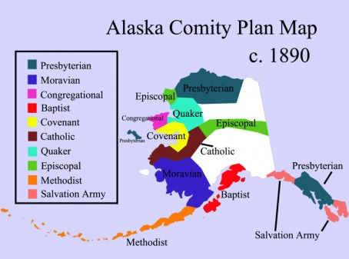
Presbytery
Presbyterian governance begins at the Presbytery and is delegated to congregation
Default place that things happen – everything not mentioned specifically in the Book of Order (G-3.0101)
Membership of the Presbytery: Congregations and Teaching Elders within its district
Commissioners are equally balanced between Ruling Elders (RE) and Teaching Elders (TE)
Moderator usually elected for a one-year term
Primary duties:
Organizing, overseeing, and dissolving congregations
Ordaining, installing, removing TEs
Ecumenical partnerships
Authorizing and training the celebration of communion
Communicating with GA/Synod and congregations
Usual organization:
Staff: Executive Presbyter & Stated Clerk
Committee on Preparation for Ministry (CPM)
Commission on Ministry (CoM)
Permanent Judicial Commission (PJC)
Other committees/commissions as needed
Mission
Great Commission: “Go, therefore, and make disciples of all nations…” (Matt. 28:19)
Presbyterian Mission Agency (PMA) – Denominational Mission
Compassion, Peace, and Justice
Disaster Assistance, Hunger Program, Peacemaking, United Nations, Office of Public Witness
Racial Ethnic & Women’s Ministries
Theology, Formation, and Evangelism
1001 New Worshipping Communities, Company of New Pastors, Congregational Ministries Publishing, Theology and Worship, Youth/College/Young Adult ministries, Evangelism, New Beginnings
World Mission
Young Adult Volunteers, World Mission Workers
Mission at Home and Abroad (~1890-1910)
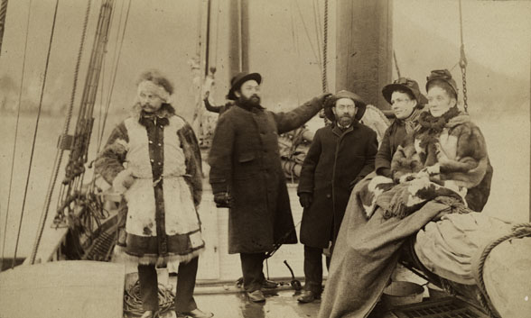
Rev. Dr. Sheldon Jackson (1834-1909)
Presbyterian Minister and General Agent of Education
Wanted to be a missionary; told he was too sickly
Established churches in Minnesota, Wisconsin, Oklahoma
Used the Railroad to establish churches in the west – a church a day!
After purchase of Alaska territory, worked to establish missions there
Brought Reindeer in to replace caribou
Divided Alaska into denominational mission regions
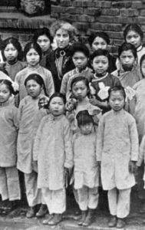
Susan Law McBeth (1830-1893)
“A theological seminary in herself”
Set up a school for teaching Native Americans in Idaho
Taught literacy, domestic, and ministry with her sister
Created a tradition of annual Camp Meeting
Donaldina Cameron (1865 - 1968)
“Angry Angel of Chinatown”
At age 25, she became superintendent of Presbyterian Home in San Francisco
Protected Chinese immigrant women from forced service
Required women to convert to Christianity to stay in the home
Reform in the Congo
Rev. Dr. William Morrison and Rev. William Sheppard
Translated Bible into Baluba (Language in the Congo) & founded newspaper
Protested abuse of native people, forced King Leopold to cede control

