Session
Union Theological Seminary, New York City
Responsible for governance of local congregation
Must be moderated by a Teaching Elder
Comprised of Ruling Elders elected and ordained by congregation
Clerk of Session elected by Session members (any ordained elder)
Provide that the Word of God may be truly preached and heard
Regular worship space + preaching of the Word
Plan and lead events in community (evangelism, reconciliation)
Ecumenical efforts bearing witness to God’s love and grace
Provide that the Sacraments be rightly administered and received
Communion (at least quarterly)
Baptism (as appropriate)
Pastoral care among congregation
Sacraments as means of grace and bringing unity to Congregation
Nurture the covenant community of Christ’s disciples
Receive/dismiss members
Train, examine, ordain, and install ruling elders (and deacons)
Lead congregation in participating in mission of whole church
Manage physical property
Bear witness against error in doctrine & immorality in congregation and community
Serve in judicial matters in accordance with Rules of Discipline
Must meet at least quarterly, and maintain records, including budgets
Fundamentalist/Modernist Controversy (c. 1890~1929)
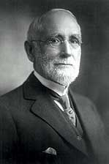
Charles Briggs, proponent of Higher Criticism
Appointed Professor of Biblical Theology at Union Seminary (1891)
Inaugural address spelled out implications of Historical Critical method, and attacked Princeton Seminary’s doctrine of scriptural inerrancy
General Assembly (1891) passed a motion to veto Brigg’s appointment.
Union Seminary refused to remove him (scholarly freedom) – withdrew from denomination
Briggs tried for heresy, and defrocked in 1893
Doctrinal Deliverance of 1910
Debate in New York Presbytery over ordination of three men who would not assent to doctrine of virgin birth
GA issued statement of five doctrines “necessary and essential” to faith
The five propositions became known as “Five Fundamentals”
Lyman Stewart, c. 1910
Lyman Stewart publishes “The Fundamentals: Testimony to the Truth”
12 pamphlets published between 1910 and 1915
Series critical of Higher Criticism, and added to the five fundamentals (dispensationalism)
Term “fundamentalist” comes from these pamphlets
The Five Fundamentals:
*Inspiration of the Bible by the Holy Spirit (and the inerrancy of scripture)
*Virgin Birth of Jesus Christ
*Christ’s Death is atonement for sin
*Bodily resurrection of Christ
*Historical Reality of Christ’s miracles
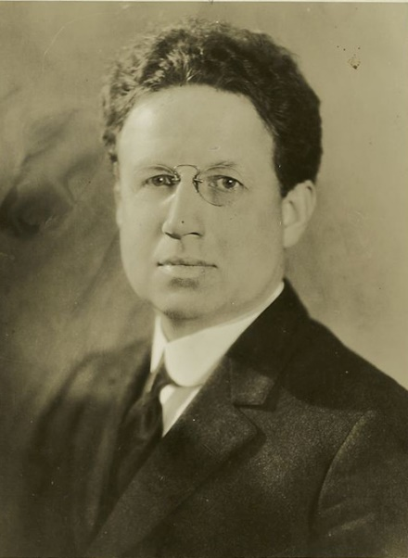
Harry Emerson Fosdick preaches “Shall the Fundamentalists Win?” (1922)
Baptist, special permission to preach at First Pres. NYC
Presented Liberal Theologians as sincere evangelical Christians, trying to make sense of science and history
Presented Fundamentalists as arbitrarily drawing the line to what was off-limits to religious discussion
Sermon packaged as a pamphlet, and sent to every Protestant pastor in the country
William Jennings Bryan and General Assembly of 1923
Bryan a staunch fundamentalist – anti-Social-Darwinism
Lost a close election to moderator of GA (1923)
Proposed that denomination should stop paying schools teaching “Darwinism”
Auburn Affirmation (1923-24)
Argued that Presbyterianism had a long tradition of freedom of interpretation
Five Fundamentals imposed from GA flew in the face of that tradition
Rev. Harry Fosdick, 1926
General Assembly of 1926
Toleration of Doctrinal Diversity was to be encouraged
GA cannot amend Confessions without Presbytery assent, but can issue binding judicial rulings within the existing Confession
Report of the Special Commission of 1925
…To What an Article Is Essential and Necessary
A decision as to any article being "essential and necessary," by whomsoever made, calls for definition of language. The question arises, essential to what? necessary to what? Is it essential and necessary to salvation? If so, the number of such articles will be reduced far below the number of chapters in the Confession of Faith. The Confession of Faith is only a subordinate standard. The supreme standard is the Word of God as the Holy Spirit speaks through it; and the Word of God declares, "Whosoever shall call upon the name of the Lord shall be saved." (Rom. 10:13.) And further, the word of faith is said to be, "If thou shalt confess with thy mouth the Lord Jesus and shalt believe in thine heart that God hath raised Him from the dead, thou shalt be saved." (Rom. 10:9.) Is an article declared to be essential and necessary to the leading of Christian life and to citizenship in the Kingdom of God? Is it held to be essential and necessary to the existence of the Church? Manifestly, it is not in these respects primarily that we are dealing with essentiality.
To what then, is an article declared to be essential and necessary? The answer would seem to be a system of doctrine. Especially so, since precisely this is what a candidate vows to receive and adopt – "a system of doctrine." It is stated sometimes that there are a number of systems of doctrine contained in the Confession of Faith – as for instance, a system of general Christian doctrines as held by all Churches; a Protestant system, and a Reformed system. It is to be feared that these distinctions are too close and scholastic for the practical purpose contemplated by the question now before us. The Church as a whole, and certainly a candidate under examination, looks upon the Confession of Faith as presenting one system of Christian truth to which the Church bears witness, and this Confession is received as "containing the system of doctrine taught in the Holy Scriptures." The Confession of Faith does not necessarily comprise all the doctrines included in the system taught in the Holy Scriptures. Indeed it does not purport to do so, but it contains that system. Moreover, there are features of the Word of God that are not doctrinal, and the lines which distinguish these one from another are not always clearly drawn. But there is broadly speaking, a "system of doctrine taught in the Holy Scriptures," and the Confession of Faith is declared to contain this system, and as such it is received and adopted by the candidate.
To declare an article of faith "essential and necessary" to this system is a serious undertaking. Undoubtedly there are articles, which all will agree fall within this classification, but there are others about which there will be differences of opinion. A doctrine may be entirely true and yet not be an "essential and necessary article" in the system. The question is not as to its truth, primarily, but, rather, is it essential to the system? And the minds of individuals, certainly the mind of the Church itself, should be deeply humble and devoutly prayerful when attempting to decide an issue of such grave import as this.

Auburn Affirmation
IV. The General Assembly of 1923 expressed the opinion concerning five doctrinal statements that each one "is an essential doctrine of the Word of God and our standards." On the constitutional grounds which we have before described, we are opposed to any attempt to elevate these five doctrinal statements, or any of them, to the position of test for ordination or for good standing in our church.
Furthermore, this opinion of the General Assembly attempts to commit our church to certain theories concerning the inspiration of the Bible, and the Incarnation, the Atonement, the Resurrection, and the Continuing Life and Supernatural Power of our Lord Jesus Christ. We all hold most earnestly to these great facts and doctrines; we all believe from our hearts that the writers of the Bible were inspired of God; that Jesus Christ was God manifest in the flesh; that God was in Christ, reconciling the world unto Himself, and through Him we have our redemption; that having died for our sins He rose from the dead and is our ever-living Savior; that in His earthly ministry He wrought many mighty works, and by His vicarious death and unfailing presence He is able to save to the uttermost. Some of us regard the particular theories contained in the deliverance of the General Assembly of 1923 as satisfactory explanations of these facts and doctrines. But we are united in believing that these are not the only theories allowed by the Scriptures and our standards as explanations of these facts and doctrines of our religion, and that all who hold to these facts and doctrines, whatever theories they may employ to explain them, are worthy of all confidence and fellowship.

