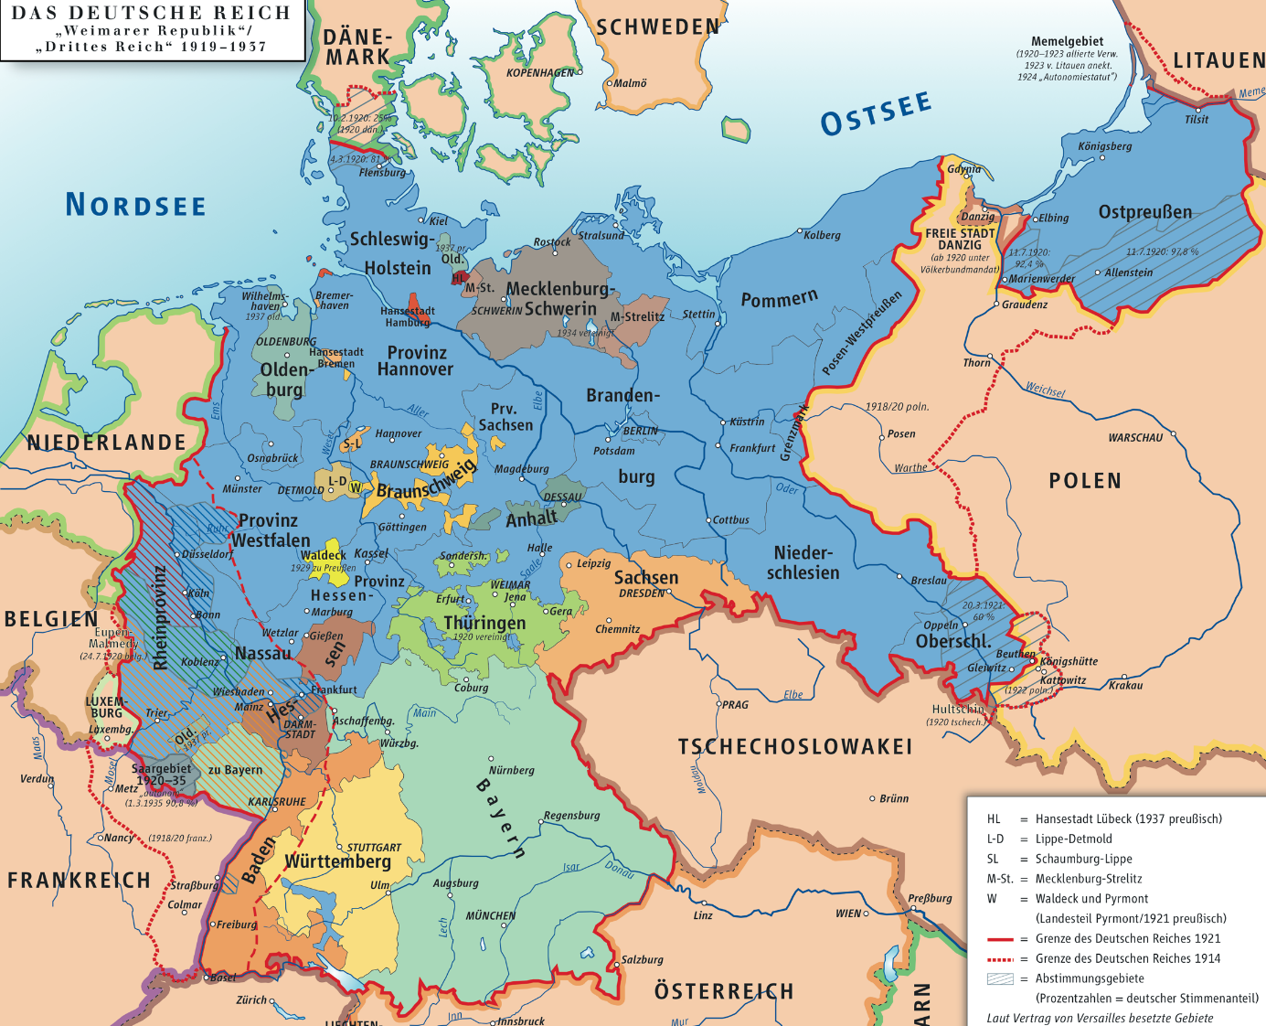
German Church (1871 – 1945)
German Empire (1871-1918) German states each supported a denomination
Four denominations: Lutheran, Reformed, United, Catholic
Church taxes were collected by the state and distributed to the church
“Free Churches” tolerated, but did not receive state funds
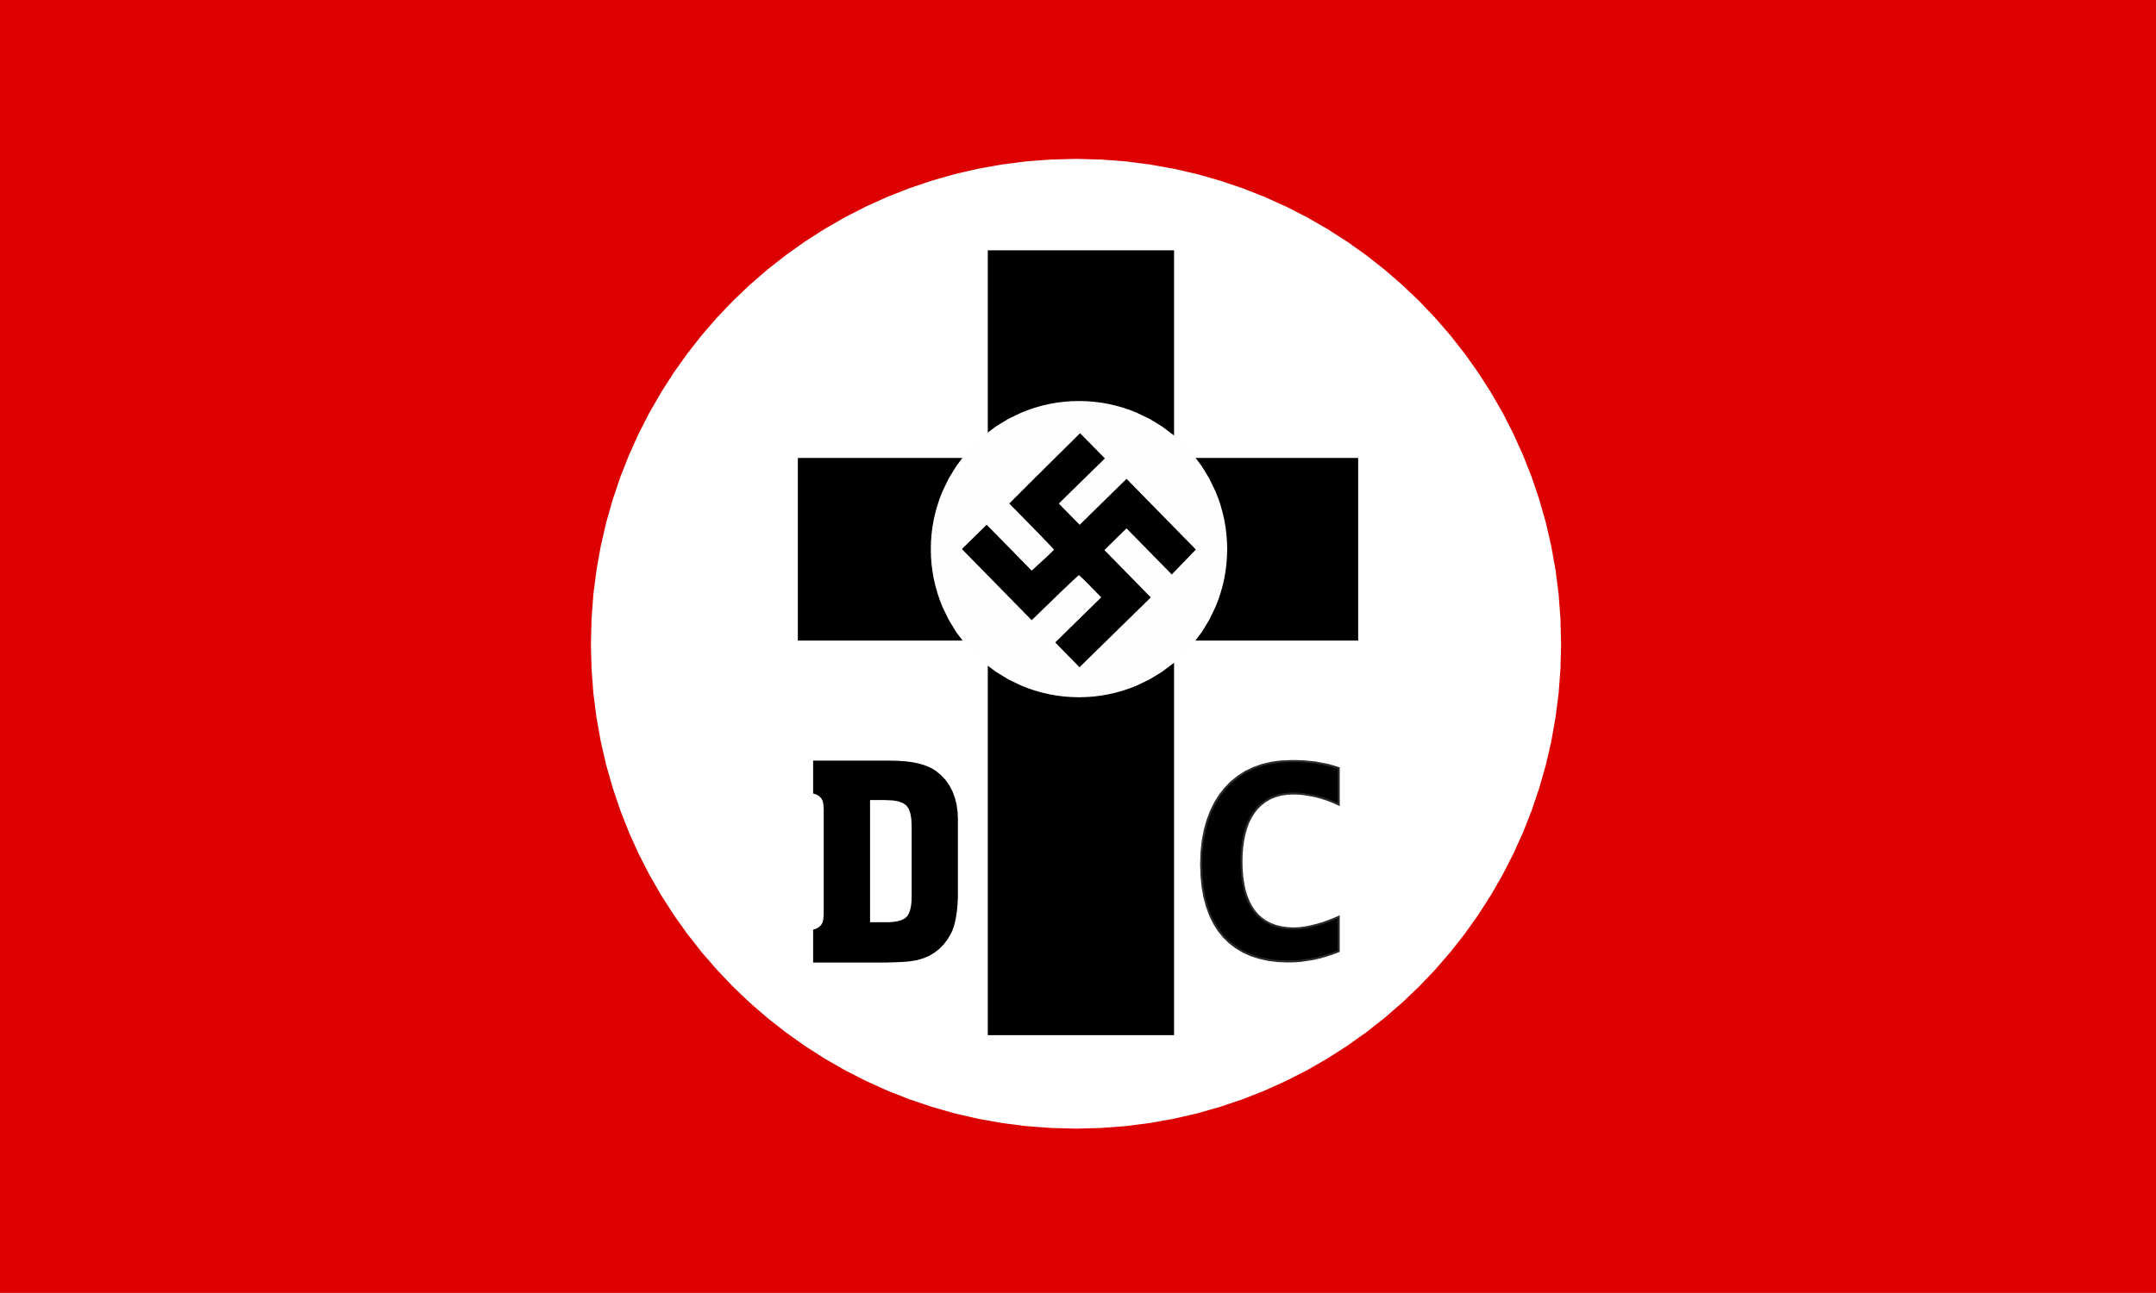
Weimar Republic (1918-1933)
State churches officially abolished, but remained “public corporation” and retained subsidies from secular government
Rights previously held by German Princes now held by 28 church councils
German Christians (1931 – 1945)
Fanatic Nazi Protestants who began in the Prussian church
Wanted to overthrow the republic for an authoritarian regime
Gained power through election in Nazi Germany (1933) in all but four states
German Christian Flag (’34)
Confessing Church (1933 – 1945)
Opposition to German Christians, demanding non-interference from Gov’t
Generally a timid response; no focus on the suffering of people (esp. Jews)
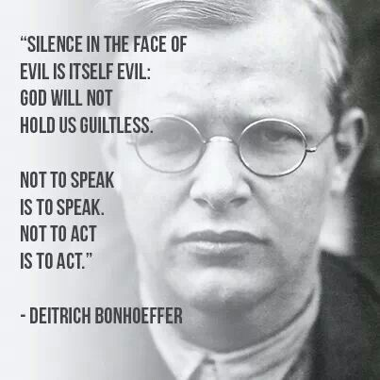
Dietrich Bonhoeffer (1906 – 1945)
German United professor, theologian, and resister
Received Dr. Theol. in Berlin at age 21; also studied at Union Seminary (NY)
Opposed Nazism, campaigned against German Christians
Wrote first draft of Bethel Confession (1933)
(Included mention of Jews as God’s chosen people)
Bethel Confession was watered down by committee, and considered too “Reformed” for adoption by all denominations
Formed Underground Seminary (1935-1943)
Killed in concentration camp for assisting with a (failed) plot to kill Hitler
Theological Declaration of Barmen (1934)
The church reminds [people] of God’s kingdom, God’s commandment and righteousness, and thereby the responsibility both of rulers and the ruled. It trusts and obeys the power of the Word through which God upholds all things. We reject the false doctrine, as though the State, over and beyond its special commission, should and could become the single and totalitarian order of human life, thus fulfilling the church’s vocation as well. ~Barmen Declaration (8.22-23)
Strong rejection of the Nazis and the German Christians
Written primarily by Karl Barth
Consists of six articles, each with an affirmation and a rejection
1 – Jesus is the one Word of God / reject any other revelation
2 – Christ forgives all sins, so claims all of life / reject any other claims
3 – Church must act as Jesus in the world / reject ideological churches
4 – No dominion of officers in the church / reject imposed leaders
5 – Separation of Church and Gov’t / reject church taking on gov’t function
6 – Freedom of church to spread message of grace / reject subordination of Word to secular plans
PC(USA) Book of Confessions
Union of PCUSA and UPCNA (1958) brought a request to revise Westminster Conf.
This task was dropped when it became too difficult
Committee reassigned to write a new confession – Conf. of 1967
With the release of the Conf. of 1967, the UPCUSA adopted the Book of Confessions
Also updated ordination question: “Agree to be guided by the Confessions”
Kept and expanded with union of UPCUSA and PCUS -> PC(USA)
Intended as “a book with no back cover” – able to be expanded as necessary
Recognition that our understanding of God’s Word changes
Recording of ways of faithful interpretation in the church

