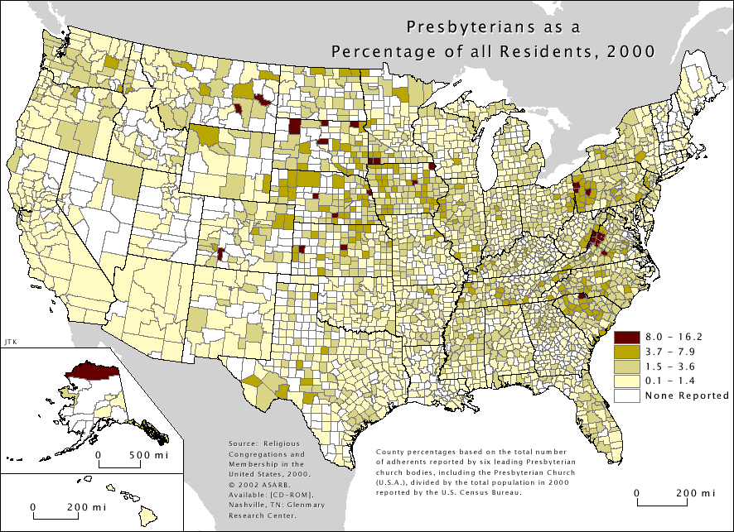
Divisions and Unifications Among Presbyterians (1954-2012)
Plans of Unification among PCUSA, PCUS + UPCNA (1954)
GA of all three decided to unite
Failed to be ratified in PCUS primarily over issue of desegregation
1958: Formation of UPCUSA
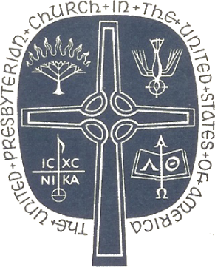
New Worship + Theology Materials
* The Hymnbook (1955) – joint effort of PCUSA, UPCNA, PCUS, Reformed Church in America and Associate Reformed Presbyterians
* Directory for Worship (1960)
* Book of Common Worship (1966)
* Worshipbook (1972) – joint effort of UPCUSA, PCUS, and Cumberland PC
* Brief Statement of Belief (PCUS, 1962)
* Confession of 1967 (UPCUSA, 1967)
Controversies and Splits
* Presbyterian Church in America (1973) – Split from PCUS over ordination of women. Later absorbed Reformed Presbyterian Evangelical Synod
* Evangelical Presbyterian Church (1981) – Split from UPCUSA over two judicial cases – Walter Kenyon and Mansfield Kaseman)
* Covenant Order of Evangelical Presbyterians (ECO) (2012) – Split from PC(USA) over ordination of people with non-heterosexual orientation
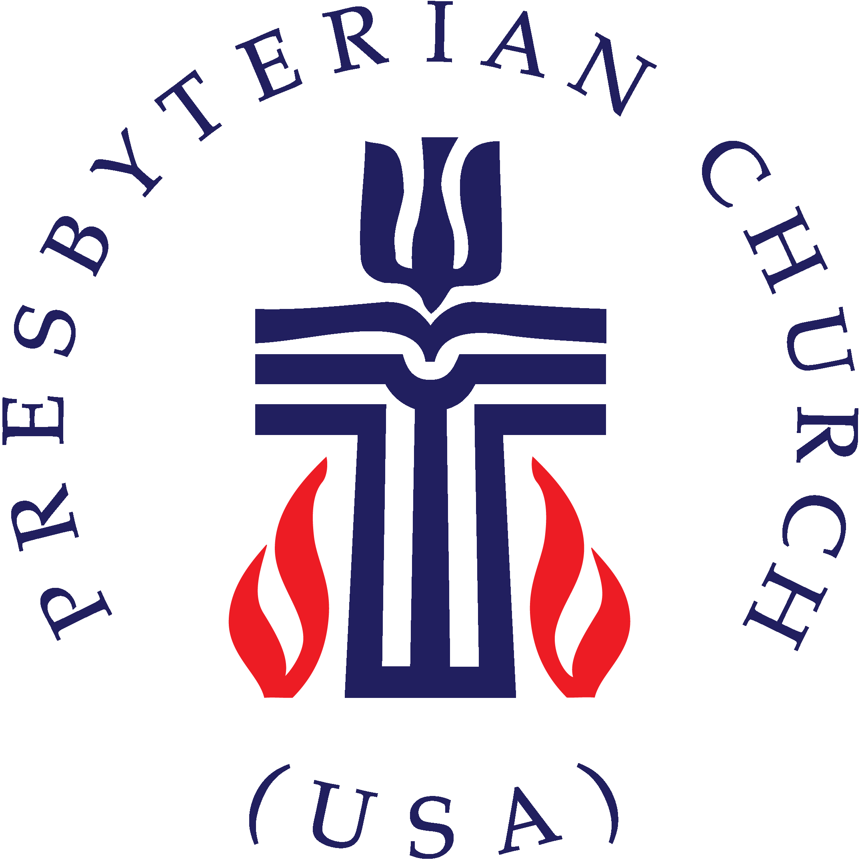
Formation of the PC(USA) (1983)
Established new headquarters in Louisville – between the former HQs of PCUS (Georgia) and the UPCUSA (NY)
Called for a new Statement of Faith for united denomination
Brief Statement of Faith (1991)
Statement of Faith for use in worship
Both PCUS and UPCUSA had tried before
Drafting Committee – “Committee of Twenty-One” (1985)
Chosen for diversity of voices: women + men; members, elders, ministers; Anglos + non-Anglos, professors and poets
Studied each of the other confessions in depth
Continual tension between “puritans and poets”
First public draft released 1988
Received over 15,000 responses – from within and outside denomination
88% from within affirmed the draft – and critiques moved equally in all directions
Revisory Committee – “Committee of Fifteen” (1989)
Tasked with making the BSF more “user-friendly”
Ten ministers, three laypersons, three professors
Worked with Committee of Twenty-One over five months
Approved by a vote of 94% at GA 1990
Theological Content:
* Echoes previous confessions – “In life and in death, we belong to God”
* Trinitarian Monotheism
* Justification of Grace through Faith
* Authority of Scripture
* God’s Sovereignty
* Election to service as well as salvation
* Children of the Covenant
* Faithful Stewardship of Creation
* Ability to unmask idolatry
* Working for justice, freedom, and peace
* First confession to include Jesus’ ministry (in addition to birth, death, and resurrection)
* First confession to explicitly affirm Human Equality (especially between women and men)
* Affirming the mystery of God through multiple Biblical references
The Brief Statement of Faith
In life and in death we belong to God.
Through the grace of our Lord Jesus Christ,
the love of God,
and the communion of the Holy Spirit,
we trust in the one triune God, the Holy One of Israel,
whom alone we worship and serve.
We trust in Jesus Christ,
Fully human, fully God.
Jesus proclaimed the reign of God:
preaching good news to the poor
and release to the captives,
teaching by word and deed
and blessing the children,
healing the sick
and binding up the brokenhearted,
eating with outcasts,
forgiving sinners,
and calling all to repent and believe the gospel.
Unjustly condemned for blasphemy and sedition,
Jesus was crucified,
suffering the depths of human pain
and giving his life for the sins of the world.
God raised this Jesus from the dead,
vindicating his sinless life,
breaking the power of sin and evil,
delivering us from death to life eternal.
We trust in God,
whom Jesus called Abba, Father.
In sovereign love God created the world good
and makes everyone equally in God’s image
male and female, of every race and people,
to live as one community.
But we rebel against God; we hide from our Creator.
Ignoring God’s commandments,
we violate the image of God in others and ourselves,
accept lies as truth,
exploit neighbor and nature,
and threaten death to the planet entrusted to our care.
We deserve God’s condemnation.
Yet God acts with justice and mercy to redeem creation.
In everlasting love,
the God of Abraham and Sarah chose a covenant people
to bless all families of the earth.
Hearing their cry,
God delivered the children of Israel
from the house of bondage.
Loving us still,
God makes us heirs with Christ of the covenant.
Like a mother who will not forsake her nursing child,
like a father who runs to welcome the prodigal home,
God is faithful still.
We trust in God the Holy Spirit,
everywhere the giver and renewer of life.
The Spirit justifies us by grace through faith,
sets us free to accept ourselves and to love God and neighbor,
and binds us together with all believers
in the one body of Christ, the Church.
The same Spirit
who inspired the prophets and apostles
rules our faith and life in Christ through Scripture,
engages us through the Word proclaimed,
claims us in the waters of baptism,
feeds us with the bread of life and the cup of salvation,
and calls women and men to all ministries of the church.
In a broken and fearful world
the Spirit gives us courage
to pray without ceasing,
to witness among all peoples to Christ as Lord and Savior,
to unmask idolatries in Church and culture,
to hear the voices of peoples long silenced,
and to work with others for justice, freedom, and peace.
In gratitude to God, empowered by the Spirit,
we strive to serve Christ in our daily tasks
and to live holy and joyful lives,
even as we watch for God’s new heaven and new earth,
praying, “Come, Lord Jesus!”
With believers in every time and place,
we rejoice that nothing in life or in death
can separate us from the love of God in Christ Jesus our Lord.
Glory be to the Father, and to the Son, and to the Holy Spirit. Amen.*
*Instead of saying this line, congregations may wish to sing a version of the Gloria

